ECOCART STORAGE AND DATABASE
Modular Assignment 3 | Storage and Database Solution
Md Habib Ahmed | IHC – Cloud Development | October 2026

1. Objective and scope
EcoCart Ltd. required a cloud-based prototype to store structured product and customer records alongside unstructured catalogue assets. I deployed Amazon RDS for MySQL and Amazon S3 in the Stockholm region (eu-north-1), populated both services with small demonstration datasets, and tested access through Python. The goal was to demonstrate relational data management, object storage, programmatic integration, backup configuration and practical security controls.

2. Architecture and deployment
The local Python client imports product and customer CSV records into RDS over an encrypted MySQL connection on port 3306. A separate boto3 script, tested in AWS CloudShell, lists and retrieves S3 objects over HTTPS. Product rows contain image_s3_key and description_s3_key values that identify corresponding files in S3. RDS is deployed within a VPC, while S3 is a regional service outside the VPC; no direct RDS-to-S3 connection was configured.
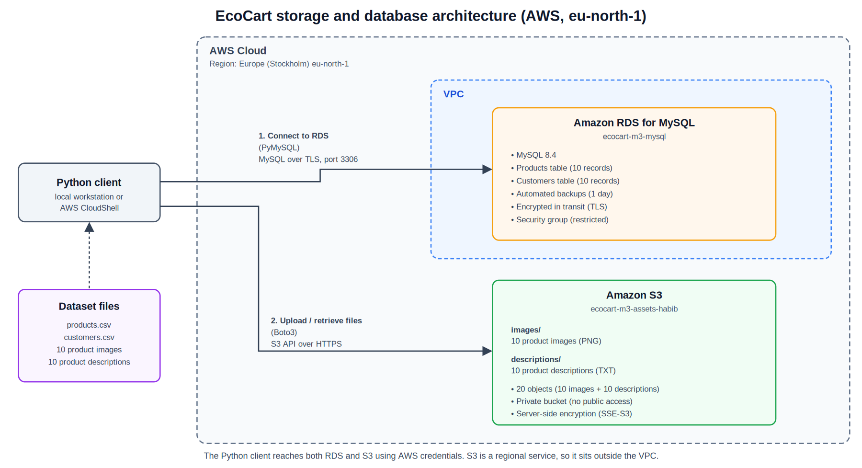
Figure 1. EcoCart architecture showing the Python client, RDS MySQL and Amazon S3.

3. Datasets and database schema
The reproducible sample includes 10 products in products.csv and 10 fictional customers in customers.csv. The products table stores product_id (primary key), name, category, price, stock, image_s3_key and description_s3_key. The customers table stores customer_id (primary key), name, email (unique) and city. SQL constraints prevent negative prices or stock. The schema is defined in database/schema.sql.

4. Relational database implementation
The database instance ecocart-m3-mysql ran MySQL 8.4 on a single-AZ db.t4g.micro instance with 20 GiB gp2 storage. The ecocart_db database and both tables were created in MySQL Workbench. scripts/import_to_rds.py loaded the CSV files using PyMySQL and repeatable insert/update statements. Credentials were entered at runtime rather than stored in source code. The client verified TLS with the AWS RDS CA bundle.
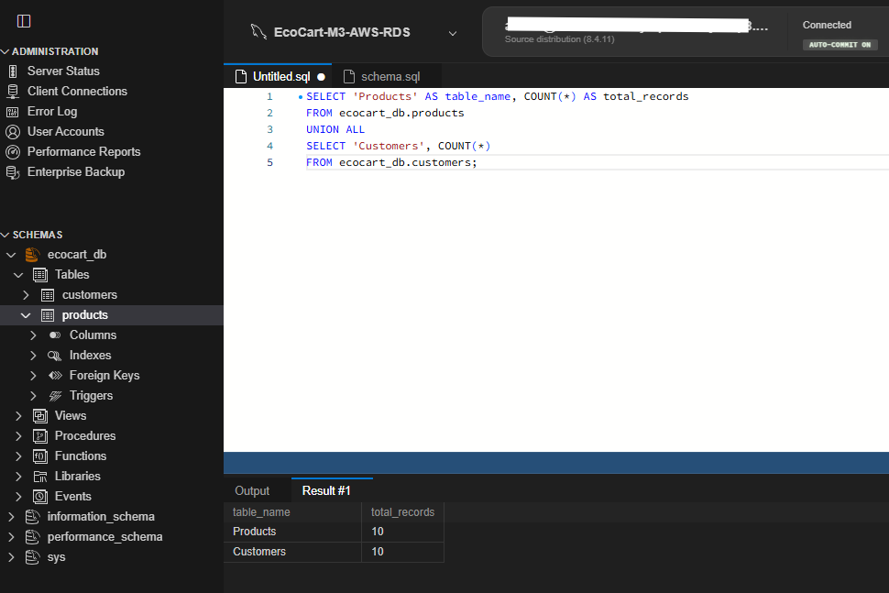
Figure 2. MySQL Workbench query confirming 10 product records and 10 customer records.

5. Object storage and SDK validation
The private bucket ecocart-m3-assets-habib stores 10 PNG images under images/ and 10 TXT descriptions under descriptions/. Public access is blocked and default server-side encryption is SSE-S3; bucket versioning was not enabled. A boto3 test in AWS CloudShell counted 10 image objects and 10 description objects and successfully retrieved descriptions/P001.txt. The reproducible verification code is in scripts/verify_s3.py.

6. Security and automated backups
The RDS instance was temporarily publicly reachable for the academic test, but inbound TCP 3306 was restricted to the workstation public IP (/32) through a security group. MySQL traffic used TLS. S3 remained private with SSE-S3 enabled. RDS automated backups were configured with a one-day retention period; the AWS console displayed an available automated snapshot and a latest restore time. A restore operation was not performed.
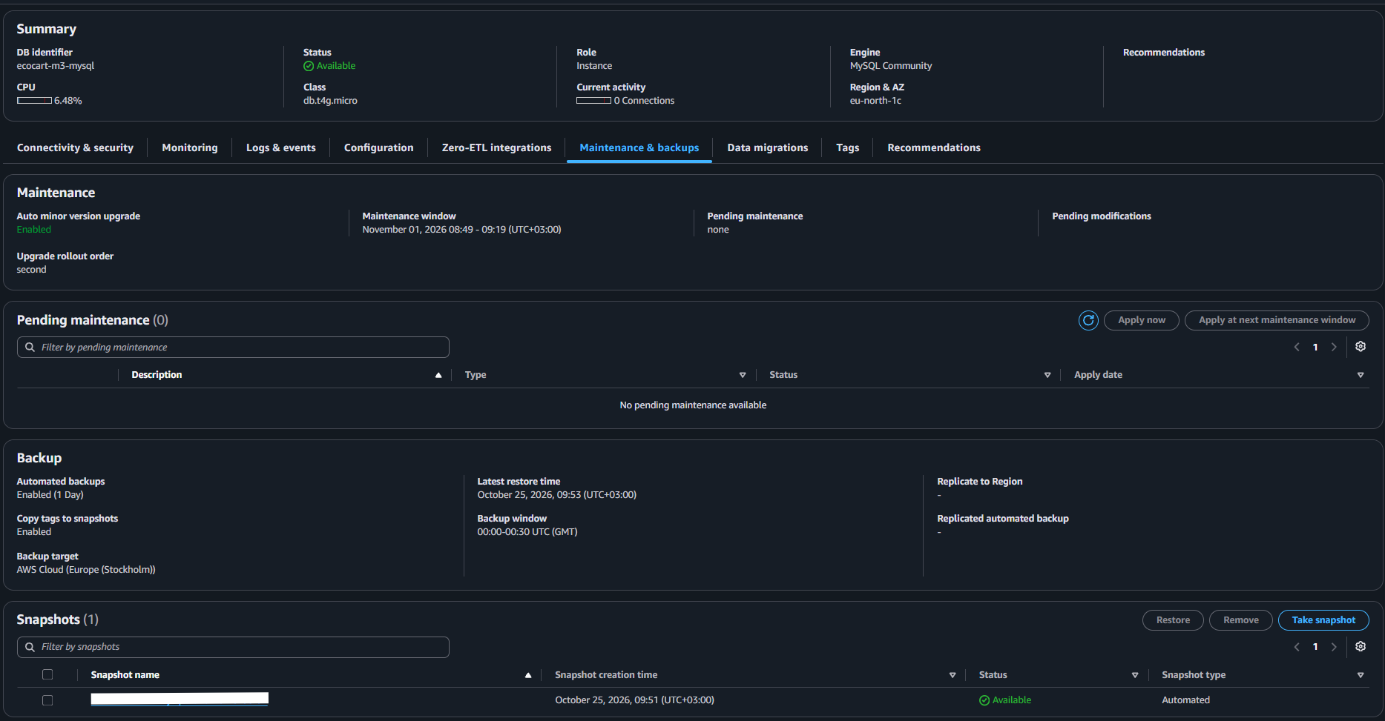
Figure 3. RDS maintenance and backup settings showing one-day automated retention and an available snapshot.

7. Integration testing and results
Validation | Method | Observed outcome
Database creation | Workbench schema execution | Two tables created
CSV import | Python / PyMySQL | 10 products; 10 customers
S3 listing | Python / boto3 | 10 PNG and 10 TXT objects
S3 retrieval | boto3 get_object | P001 description read
Backup availability | RDS console | Automated backup enabled; snapshot available
The results verify the sample-data workflow, not production performance or high availability. No load benchmark, failover exercise or database restore drill was conducted.

8. Cost and operational limitations
The prototype used a small single-AZ database and a small S3 object set. The RDS instance was stopped after testing to pause instance-hour charges; provisioned storage and backup-related charges can continue while stopped, and AWS can automatically restart the instance after seven days. The final resource deletion remains a separate cleanup action. Actual project-specific charges were not measured.

9. Conclusion and reproducibility
The implementation demonstrates a clear separation between relational records in MySQL and product files in S3. Verified Python ingestion and object retrieval show that the two storage models can be used together through application-layer object keys. A production deployment should place RDS in private subnets, strengthen IAM least privilege, configure monitoring and longer-term recovery objectives, and test restore procedures.
The GitHub repository includes the SQL schema, datasets, images, descriptions, Python scripts, architecture diagram, evidence and report. The demonstration is reproducible with an appropriately configured AWS account and database credentials; no passwords or long-lived AWS access keys are required in the repository.
Evidence and setup: README.md, database/schema.sql, scripts/ and docs/evidence/ in https://github.com/mdhabibhameedi/ecocart-storage-database-solution

